**WEEKLY ASSIGNMENT 1**

**Total Time: 2 Hrs**

**Total Marks: 100**

1. **Short Questions (Best of 10) (Total Marks: 10x2 = 20)**
2. **What are the main features of OOP?**

**Main features of OOP include classes and objects. Encapsulation, abstraction, inheritance and polymorphism.**

1. **What is encapsulation, Explain with code example?**

**Encapsulation is where we bind and show only selected information, and an example is where we set to private.**

**Public class student {**

**Private string address**

**Public string name**

1. **What is Polymorphism, explain with code example?**

**Polymorphism is where a class has many forms. It is observed in function overriding and overloading e.g. for overloading we have**

**Public static int printArea(int length, int breadth)**

**Public static int printArea(float length, float breadth)**

**Printarea(4.5f, 5.0f)**

**And it will call the float method**

1. **What is Compile time Polymorphism and how is it different from Runtime Polymorphism, explain with code example?**

**Compile time is before the code runs, and runtime is during the code runs**

1. **Explain different stages of C# program compilation and execution?**

**Code in C# > C# complier > Intermediate language > just in time Common language runtime**

1. **Explain with example what are the difference between Common Type System (CTS) and Common Language Specification (CLS)?**

**Common type system is based on data types e.g. value (int) and reference (e.g class)**

**Common language specification is based on languages compatible e.g. java, python**

**Common language specification is a subset of common type system.**

**Example is**

1. **What is Just In Time (JIT) Compilation?**

**JIT stands for Just In Time. It is a compiler that converts the intermediate code into the native language during the execution. converts complied code into machine instructions**

1. **Write the Code for Defining an array of 10 variables of Integer type?**

**Int [] numbers = new int[10]**

1. **What is the difference between Int32 and Int64 class?**

**Int32 reads up to 2^32, and int64 reads up to 2^64**

1. **What are different Types of SDLC models?**

**Waterfall, iterative waterfall and agile**

1. **Discuss the advantages and disadvantages of a waterfall Model?**

**Advantage – fixed approach and sticking to good plan**

**Disadvantage – cannot get feedback and go back**

1. **Objective Questions (15x1= 15 Marks)**
2. **Which Type of Class Inheritance is not supported by C#?**

* **Multilevel Inheritance**
* **Multiple Inheritance**
* **Hierarchical Inheritance**
* **Abstract Class Inheritance**

1. **See the above example and state whether statements are True or False (5 marks)**

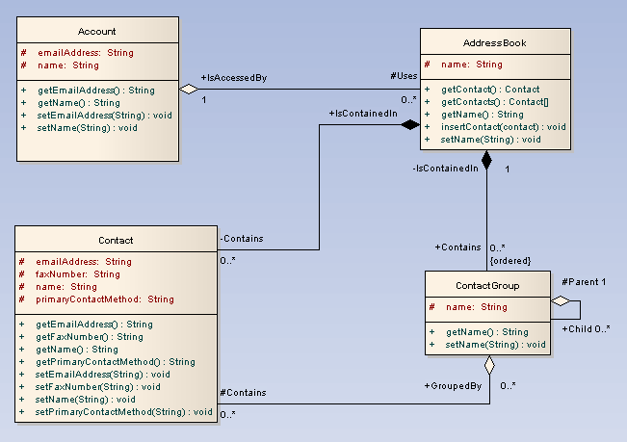

* **Each Account object can be associated to only one AddressBook object. True**
* **Each contact object must be associated with a ContactGroup object False**
* **Each ContactGroup object cannot be associated with another contact group object False**
* **Each AddressBook object must be associated to at least one Contact object. True**
* **Each ContactGroup object can be associated to more than one AddressBook object False**

|  |  |  |  |  |  |  |  |
| --- | --- | --- | --- | --- | --- | --- | --- |
|  | 1. **Which of the following are the correct ways to increment the value of variable a by 1?** 2. **++a++;** 3. **a += 1;** 4. **a ++ 1;** 5. **a = a +1;** 6. **a = +1;**  |  | | --- | | 1. **Which of the following is NOT an Arithmetic operator in C#.NET?** 2. **\*\*** 3. **+** 4. **/** 5. **%** 6. **\*** | |  | | 1. **Which of the following is NOT a Bitwise operator in C#.NET?** 2. **&** 3. **|** 4. **<<** 5. **^** 6. **~** | | |  | | --- | | 1. **Which of the following statements is correct about the C#.NET code snippet given below?**   **int d;**  **d = Convert.ToInt32( !(30 < 20) );** | | 1. **A value 0 will be assigned to d.** 2. **A value 1 will be assigned to d.** 3. **A value -1 will be assigned to d.** 4. **The code reports an error.** 5. **The code snippet will work correctly if ! is replaced by Not.** 6. **What will be the output of the following code snippet?**   int i = 30;  int j = 5 % 5;  if (Convert.ToBoolean(Convert.ToInt32(i != j)))  {  Console.WriteLine("if Clause executed");  }  else  {  Console.WriteLine("else Clause executed");  }  Console.WriteLine("Entered Main Function");  Console.ReadLine();  **Output:**  **A. if Clause executed B. else Clause executed C.  if Clause executed Entered Main Function D. else Clause executed Entered Main Function** | | |

1. **What will be the output of the following code snippet?**

int a, b;

for (a = 2; a >= 0; a--)

{

for (b = 0; b <= 2; b++)

{

if (a == b)

{

Console.WriteLine("1");

}

else

{

Console.WriteLine("0");

}

}

Console.WriteLine("\n");

}

**Output:**

**A. 1 0 0  
0 1 0  
0 0 1  
B. 0 1 0  
1 0 0  
0 0 1  
C.  0 0 1  
0 1 0  
1 0 0  
D. 1 0 0  
0 0 1  
0 1 0**

1. **What will be the output of the following C# code?**
2. **int** i;
3. **for** (i = 0; ; )
4. {
5. Console.WriteLine("hello");
6. }
7. Console.ReadLine();

**a) No output  
b) hello  
c) hello printed infinite times  
d) Code will give error as expression syntax**

1. **What will be the output of the following C# code?**
2. **float** f;
3. **for** (f = 0.1f; f <= 0.5; f += 1)
4. Console.WriteLine( ++f );
5. Console.ReadLine();

**a) 1.1  
b) 0.1  
c) 0.1 0.2 0.3 0.4 0.5  
d) None of the mentioned**

1. **What will be the output of the following C# code?**
2. **int** I, J = 0;
3. **for** (I = 1; I < 10; ) ;
4. {
5. J = J + I;
6. I += 2;
7. }
8. Console.WriteLine("Sum of first 10 even numbers is:"+J);
9. Console.ReadLine();

**a) 1 2 3 4 5 6 7 8 9  
b) 25  
c) 1  
d) Run time error**

1. **Programming Questions (Answer any 4) – (15x4 = 60)**
2. **Given an array of size N containing only 0s, 1s, and 2s; sort the array in ascending order.**

**Input:**

N = 5

arr[]= {0 2 1 2 0}

**Output:**

0 0 1 2 2

1. **Given an unsorted array A of size N that contains only non-negative integers, find a continuous sub-array which adds to a given number S.**

**Example 1:**

**Input:**

N = 5, S = 12

A[] = {1,2,3,7,5}

**Output:** 2 4

**Explanation:** The sum of elements

from 2nd position to 4th position is 12.

**Example 2:**

**Input:**

N = 10, S = 15

A[] = {1,2,3,4,5,6,7,8,9,10}

**Output:** 1 5

**Explanation:** The sum of elements

from 1st position to 5th position

is 15.

1. **Given an array arr[] of N non-negative integers representing the height of blocks. If width of each block is 1, compute how much water can be trapped between the blocks during the rainy season.**

**Example 1:**

Input:

**N = 6**

**arr[] = {3,0,0,2,0,4}**

Output:

**10**

Explanation:

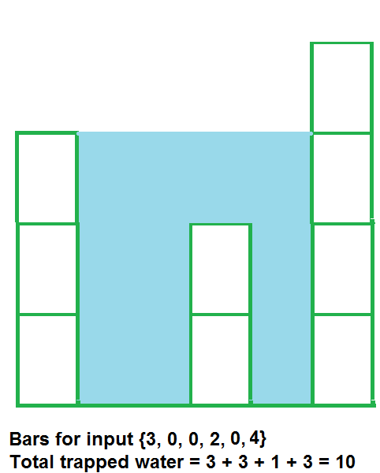

1. **Let the input string be “i like this program very much”. The function should change the string to “much very program this like i”**

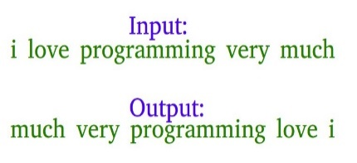

1. **Find whether a string is palindrome or not?**

**Example:** “121” is palindrome as the reverse of the string is “121” which is same

“ABCDFAB” is not palindrome

1. **Given two numbers find the GCF (Greatest Common Factor) and LCM (Lowest Common Multiple) of the two numbers**

**Example:** The GCF and LCM of 3,5 is 1 and 15. The GCF and LCM of 12, 18 is 6 & 36

1. **Design Question (1x5 = 5 marks)**
2. Imagine You oversee a Library system where the students can borrow books and return Books. As well as Librarian needs to have the option to issue book and accept return of books from students.

How would you design such a system? You are expected to create a Class diagram only showing the interactions and not needed to code or show outputs. You can use paint/ Word etc to create the diagram and attach with your answer.

Library base class, can make a main library which contains books

Class library

.type of books

Class books : library

. Public string author

. Public string title

Class returnBooks

.public string date

.public string title

Create a class student for which student to borrow book name

Class student : books

.books

.student name

.Student id

.date borrowed

Main method to call all the classes created

e.g.

library newlibrary = new library

book book1 = new book()

book1.author = “JK Rowling”